**Homework B Instructions**

**Part A:** Indicate which (if any) normal form violations exist in the following examples:

1. STUDENT (StudentNo, StudentName, Student Address, StudentMajor)

Violation?

***Violates 3rdNF because non-key attributes are determined by other non-key attributes.***

***Violates BCNF because non-prime attributes can be used to determine prime attributes.***

1. Property# below is the Primary Key

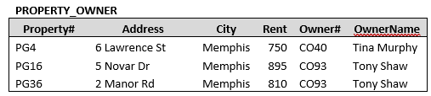

Violation?

***Violates 3rdNF.***

***Violates BCNF. Owner# and OwnerName exhibit transitive dependency in this context. Must create a separate table with columns “Owner#” and “OwnerName.” Additionally, the Address column can be used as an alternative primary key which is more informative than the Property#.***

**Part B:**

This case study is based on Ajax Vacation Rentals (a fictitious inspection company) that rents vacation homes in the mountains for owners. The Rental Report will show the rental date information and the inspector who inspected the property after the completion of the rental. Examples of the Ajax Vacation Rental Report are presented below.

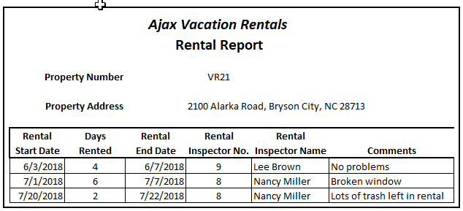

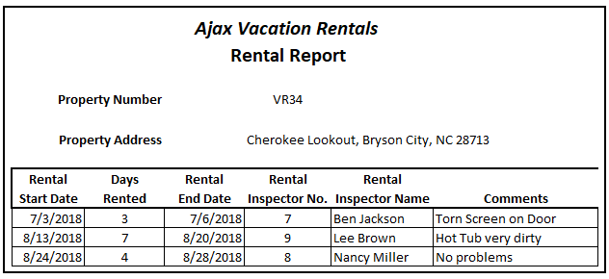

1. 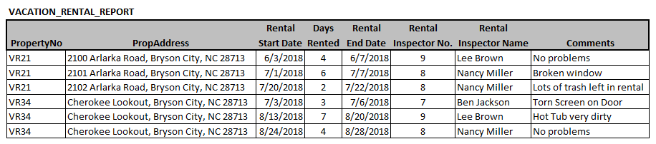Convert the form above into a table of information. Note: You will be expected to be able to do this when looking at a form(s). To help you get started this has been done as seen below.
2. What is the Primary Key of the table above?

***It is a composite determinant: PropertyNO, Start Date. Or alternatively, PropertyNO, End Date***

1. Is the table above in 1st Normal Form?  ***Yes***

1. Transform the table above into 2nd Normal Form. Begin by indicating if it is in 2NF or not and then identify all the dependencies.
   1. In 2NF ? ***NO, the original table exhibits partial dependency. However, with more instances added to the same table partial dependency might be reduced or eliminated. In this case with this number of rows, rental start or end date are candidate keys.***
   2. Dependencies include;

***Days Rented can be determined by subtracting rental start date from rental end date.***

***Rental Inspector Name and rental Inspector Number can determine one another.***

***PropertyNo and Property Address can determine one another.***

* 1. Put the table in 2NF using Sentence Structure:

Sentence Structure:

***PROPERTIES (PropertyNo, PropertyAddress)***

***RENTALS (PropertyNo, StartDate, EndDate, DaysRented, InspectorNo, Comments)***

***INSPECTORS (InspectorNo, InspectorName)***

1. Transform the table(s) in #4 above into 3RD Normal Form. Begin by indicating if it is in 3NF or not and then identify all the dependencies.
   1. In 3NF? ***NO. Original Table exhibits transitive dependency. DaysRented -> RentalStartDate & RentalEndDate -> PropertyNo***
   2. Dependencies include;

***Days Rented can be determined by subtracting rental start date from rental end date.***

***Rental Inspector Name and rental Inspector Number can determine one another.***

***PropertyNo and Property Address can determine one another.***

* 1. Put the table in 3NF:

***PROPERTIES (PropertyNo, PropertyAddress)***

***RENTALS (PropertyNo, StartDate, EndDate, DaysRented, InspectorNo, Comments)***

***INSPECTORS (InspectorNo, InspectorName)***

1. Transform the table(s) in #5 above into BCNF Normal Form. Begin by indicating if it is in BCNF or not and then identify all the dependencies.
   1. NO. Original table is Not in BCNF, because primary key can be determined by referencing non-key attribute.

Dependencies:

***Days Rented can be determined by subtracting rental start date from rental end date.***

***Rental Inspector Name and rental Inspector Number can determine one another.***

***PropertyNo and Property Address can determine one another.***

BCNF format:

***PROPERTIES (PropertyNo, PropertyAddress)***

***RENTALS (PropertyNo, StartDate, EndDate, DaysRented, InspectorNo, Comments)***

***INSPECTORS (InspectorNo, InspectorName)***

1. Is the relation shown in #6 above in 4NF? If not, why not?

***It is in 4NF as there are no multivalued dependencies.***

1. See #8 on the next page….

***NOTE: In the above exercises, I tried to use BCNF immediately, and therefore I repeated answers. To the best of my understanding, this is what you wanted, but I’m not sure! Ready to learn the right way if this isn’t it.***

1. When you have a form with many obvious relations, sometimes it is easier to simply begin by circling the fields and identifying each relation. Try to identify each relation (and fields) below. Afterwards, add any needed surrogate keys and show all the relations in a sentence structure. Be sure to use your italics, underline, and correct capitalization and include needed foreign keys.



**As one table:**

**PURCHASES (*PONumber,* VendorNO*,* PODate, CustomerName, ShippingAddress, ItemNumber, Description, Quantity, Price, Extension, VendorNO, ExpectedShipDate)**

**4th Normal Form:**

**PURCHASEORDERS (*PONumber*, VendorNO, PODate, Extension, ExpectedShipDate)**

**ORDERITEMS (*PONumber*, ItemNumber, Quantity, Extension)**

**CUSTOMERS (*VendorNumber*, *VendorName, ShippingAddress*)**

**ITEMS *(ItemNumber*, *Description*, Price)**